**REPORT ON**

**AWARENESS ABOUT MUTUAL FUNDS**

**SUBMITTED TO:- SUBMITTED BY:-** MS. SONIA KAMBOJ JANVI AGGARWAL(22504012)

SAMIKSHA KANOJIA (22504009)

SIDDHIKA KEDIA (22504017)

KHUSHI SAINI (22504013)

SOUMYA SAJAL(22504008)

**ABSTRACT**

Mutual fund industry in India is gaining a lot of popularity from the past few years. Earlier only UTI enjoyed the monopoly in this industry but with the passage of time many new players entered the market, due to which the UTI monopoly breaks down and the industry faces a severe competition. As the time passes this industry has become a buzz word in the Indian financial system. So it is very important to know the investors’ perception about this industry. Investment in a mutual fund is less risky than financing in other risky instruments, is therefore a safer option for risk averse investors. Mutual Funds offer a stage for an investor to contribute to the Indian capital market with specialized fund management regardless of the amount invested. Earlier investors used to invest directly in the stock market and many times suffered from loss due to wrong speculation. But with the coming up of mutual funds, which were handled by efficient fund managers, the investment risks were lowered by a great extent. The diversified investment structure of mutual funds and diversified risk contributed tremendously in the growth of mutual funds. This paper attempts to study the outlook of citizens towards awareness with special reference to mutual funds. The population of the study is selected from the Patel Nagar area of NEW DELHI. The sample size is 50 .The findings of this study are that people are aware of mutual funds but still, people are not investing in mutual funds.

**INTRODUCTION**

A mutual fund is a type of financial vehicle made up of a pool of money collected from many investors to invest in securities like stocks, bonds, money market instruments, and other assets. Mutual funds are operated by professional money managers, who allocate the fund's assets and attempt to produce capital gains or income for the fund's investors. A mutual fund's portfolio is structured and maintained to match the investment objectives stated in its prospectus. Mutual funds give small or individual investors access to professionally managed portfolios of equities, bonds, and other securities. Each shareholder, therefore, participates proportionally in the gains or losses of the fund. Mutual funds invest in a vast number of securities, and performance is usually tracked as the change in the total market cap of the fund—derived by the aggregating performance of the underlying investments

A strong financial market with broad participation is essential for a developed economy. With this broad objective, India’s first mutual fund was the establishment in 1963, namely, Unit Trust of India (UTI), at the initiative of the Government of India and Reserve Bank of India ‘ to encourage saving and investment and participation in the income, profits, and gains accruing to the Corporation from the acquisition, holding, management, and disposal of securities.

The history of Mutual Funds in India can be broadly divided into five distinct phases as follows:

**FIRST PHASE - 1964-1987**

The Mutual Fund industry in India started in 1963 with the formation of UTI in 1963 by an Act of Parliament and functioned under the Regulatory and administrative control of the Reserve Bank of India (RBI). In 1978, UTI was de-linked from the RBI and the Industrial Development Bank of India (IDBI) took over the regulatory and administrative control in place of RBI.

**SECOND PHASE - 1987-1993 - ENTRY OF PUBLIC SECTOR MUTUAL FUNDS**

The year 1987 marked the entry of public sector mutual funds set up by Public Sector banks and Life Insurance Corporation of India (LIC) and General Insurance Corporation of India (GIC). SBI Mutual Fund was the first ‘non-UTI’ mutual fund established in June 1987, followed by Canbank Mutual Fund (Dec. 1987), Punjab National Bank Mutual Fund (Aug. 1989), Indian Bank Mutual Fund (Nov 1989), Bank of India (Jun 1990), Bank of Baroda Mutual Fund (Oct. 1992). LIC established its mutual fund in June 1989

**THIRD PHASE - 1993-2003 - ENTRY OF PRIVATE SECTOR MUTUAL FUNDS**

The Indian securities market gained greater importance with the establishment of SEBI in April 1992 to protect the interests of the investors in the securities market and to promote the development of, and to regulate, the securities market.

In the year of 1993,the first set of SEBI Mutual Fund Regulations came into being for all mutual funds, except UTI. The erstwhile Kothari Pioneer (now merged with Franklin Templeton MF) was the first private sector MF registered in July 1993. With the entry of private sector funds in 1993, a new era began in the Indian MF industry, giving the Indian investors a wider choice of MF products.

**FOURTH PHASE - SINCE FEBRUARY 2003 – APRIL 2014**

In February 2003, following the repeal of the Unit Trust of India Act 1963, UTI was bifurcated into two separate entities, viz., the Specified Undertaking of the Unit Trust of India (SUUTI) and UTI Mutual Fund which functions under the SEBI MF Regulations. With the bifurcation of the erstwhile UTI and several mergers taking place among different private sector funds, the MF industry entered its fourth phase of consolidation.

**LITERATURE REVIEW**

**KCN Rao (2020) :** investigated that most of the investors are aware of various schemes of mutual funds. The Mutual Fund investors mainly belong to the age group from 19 years to 55 years and fall in the income group of Rs 30,000 to Rs 70,000 and above. Diversification of portfolio and tax benefit is the main factor of mutual funds that allure the investors.

**Tripathi & Japee (2020) :** found that most of the mutual funds are performing well. The researcher selected 15 different mutual fund schemes and separated them by large-cap, midcap, and small-cap. They used financial ratios for the study.

**Saxena & Sheikh (2019) :** found from the study that gender is no impact on mutual fund investment intention however middle age group, high-income group and investors with finance-related education are highly positive about mutual funds’ investments. One-way ANOVA and independent sample T-test have been used to analyses the data.

**OBJECTIVES**

As the human behaviour is unpredictable, this study helps in finding out the necessary facts regarding investors’ opinion and perceptions regarding mutual fund investment. The main objectives of the study are:

1. To study the growth of mutual fund industry in India.
2. To analyse the investors awareness and perception regarding investing in mutual funds.
3. To find out the investors opinion regarding major deficiencies in the working of the mutual fund industry.
4. To assess the association between annual household income of respondents and category of mutual fund investment .

**RESEARCH METHODOLOGY**

The scope of the study is to track out the investors’ preferences, priorities and their

awareness towards different mutual fund schemes. Keeping in view the various constraints the scope of the study is limited only to the investors residing in Patel Nagar NEW DELHI Data for the study is collected from a sample of 70 investors by using random sampling. Out of all the questionnaires 50 questionnaires are considered valid for the purpose of the study.

**SAMPLE AREA :- PATEL NAGAR, NEW DELHI**

**SAMPLE SIZE:- 70 RESPONDENTS**

**SAMPLE UNIT :- STUDENTS, TEACHERS AND RESIDENTS IN PATEL NAGAR**

**ANALYSIS AND INTERPRETATION**

For the case of understanding and making meaningful inferences, the data has been compiled in tables/graphs/diagrams.

**AGE GROUP**

|  |  |
| --- | --- |
| OPTIONS | REPONSES |
| 18-25 | 66.7% |
| 25-34 | 13% |
| 34-44 | 13% |
| 44 ABOVE | 7.4% |

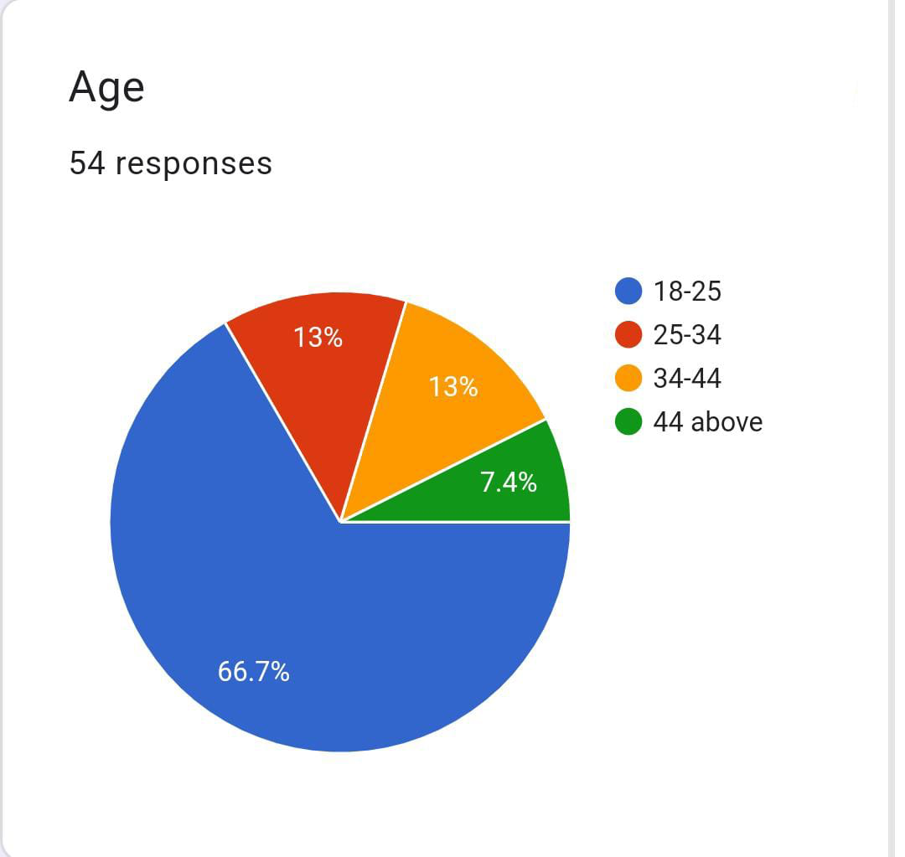

**GENDER GROUP**

|  |  |
| --- | --- |
| **OPTION** | **RESPONSES** |
| **MALE** | **37%** |
| **FEMALE** | **63%** |
| **OTHER** | **NULL** |

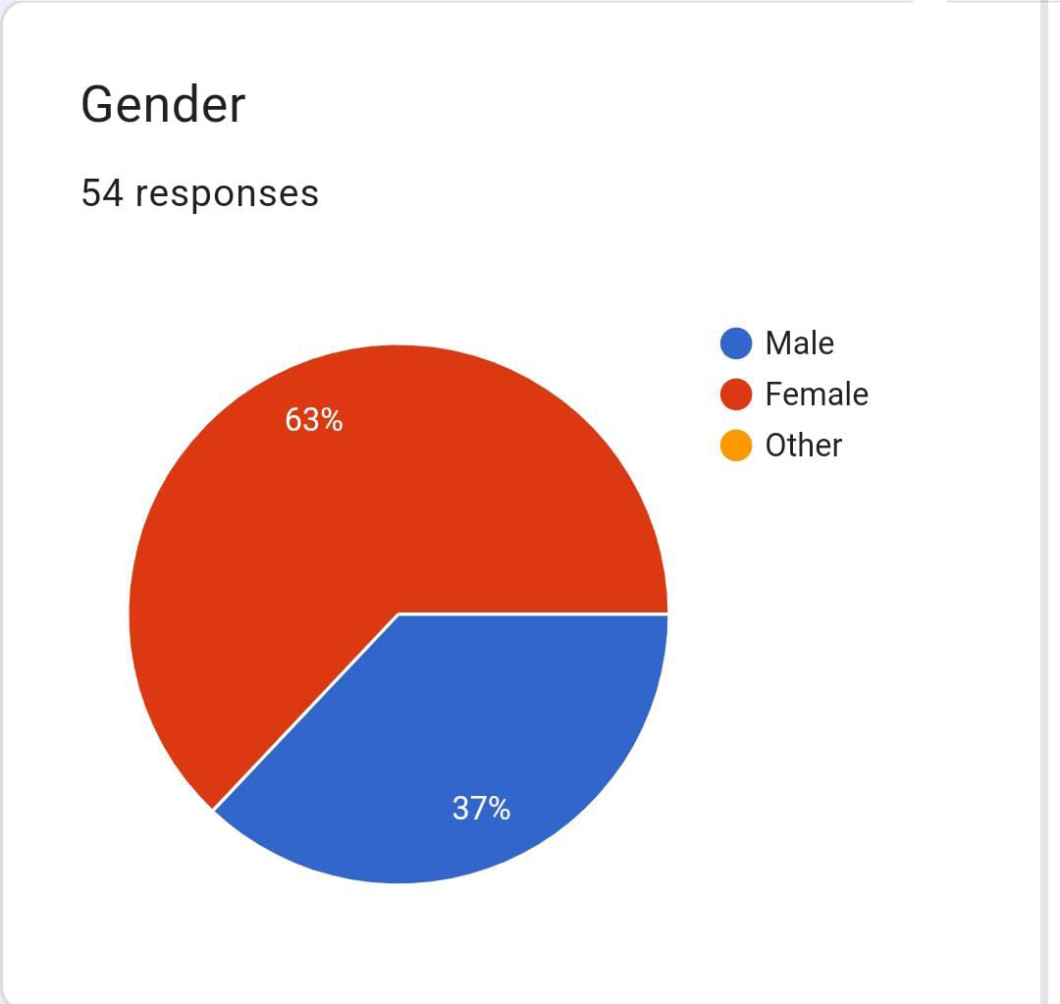

**EDUCATI0ONAL LEVEL**

|  |  |
| --- | --- |
| **OPTION** | **RESPONSES** |
| **SENIOR SECONDARY** | **16.7%** |
| **BACHELOR’S DEGREE** | **63%** |
| **MASTER’S** | **14.8%** |
| **PROFESSIONAL DEGREE** | **5.6%** |

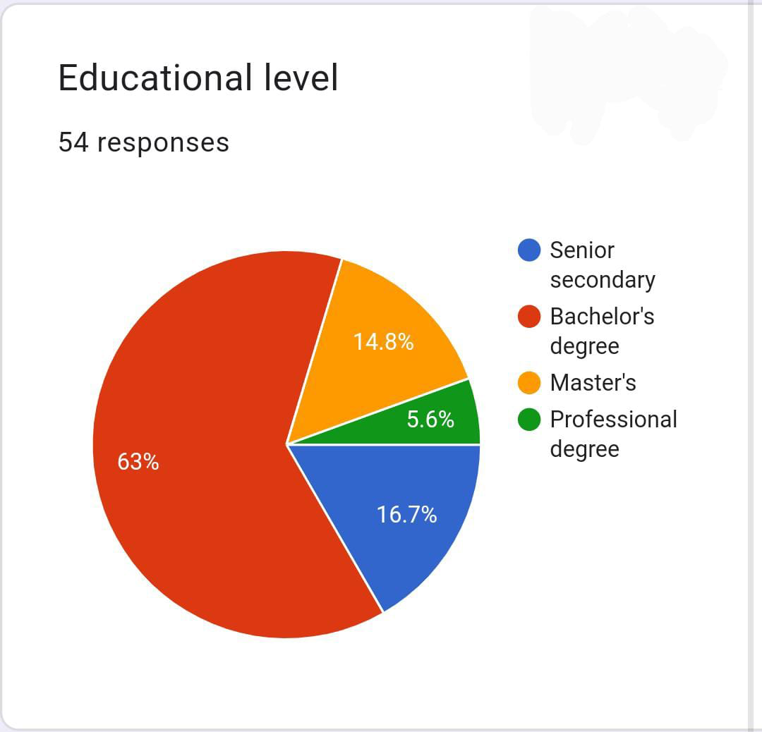

**EMPLOYMENT STATUS**

|  |  |
| --- | --- |
| **OPTIONS** | **RESPONSES** |
| **EMPLOYED FULL TIME** | **20.4%** |
| **EMPLOYED PART TIME** | **11.1%** |
| **UNEMPLOYED** | **1.84%** |
| **STUDENT** | **59.3%** |
| **HOMEMAKER** | **1.84%** |
| **RETIRED** | **1.84%** |
| **OTHER** | **1.84%** |
| **BUSINESSMEN** | **1.84%** |

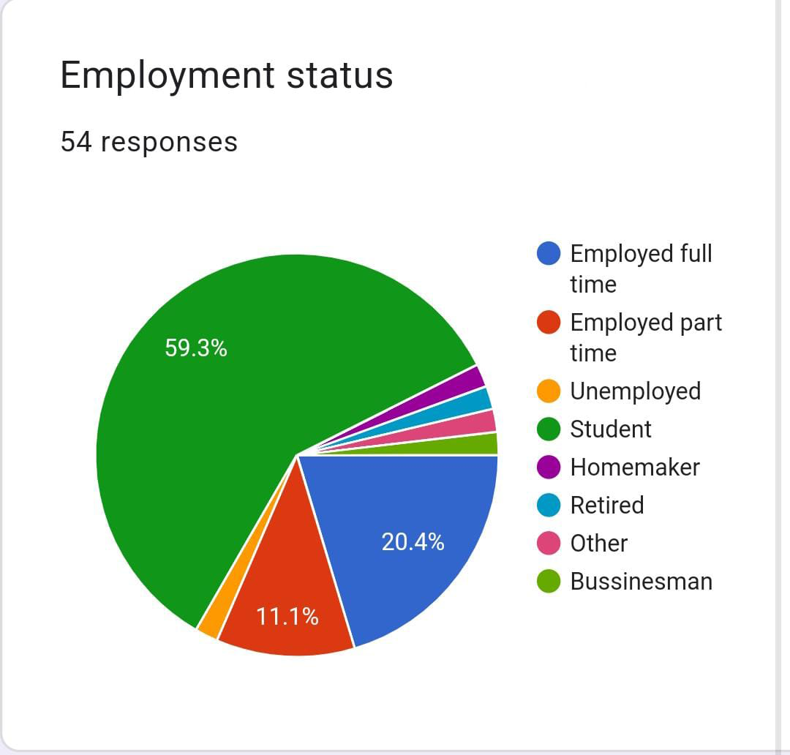

**MARITAL STATUS**

|  |  |
| --- | --- |
| **OPTION** | **RESPONSES** |
| **SINGLE** | **72.2%** |
| **MARRIED** | **27.8%** |

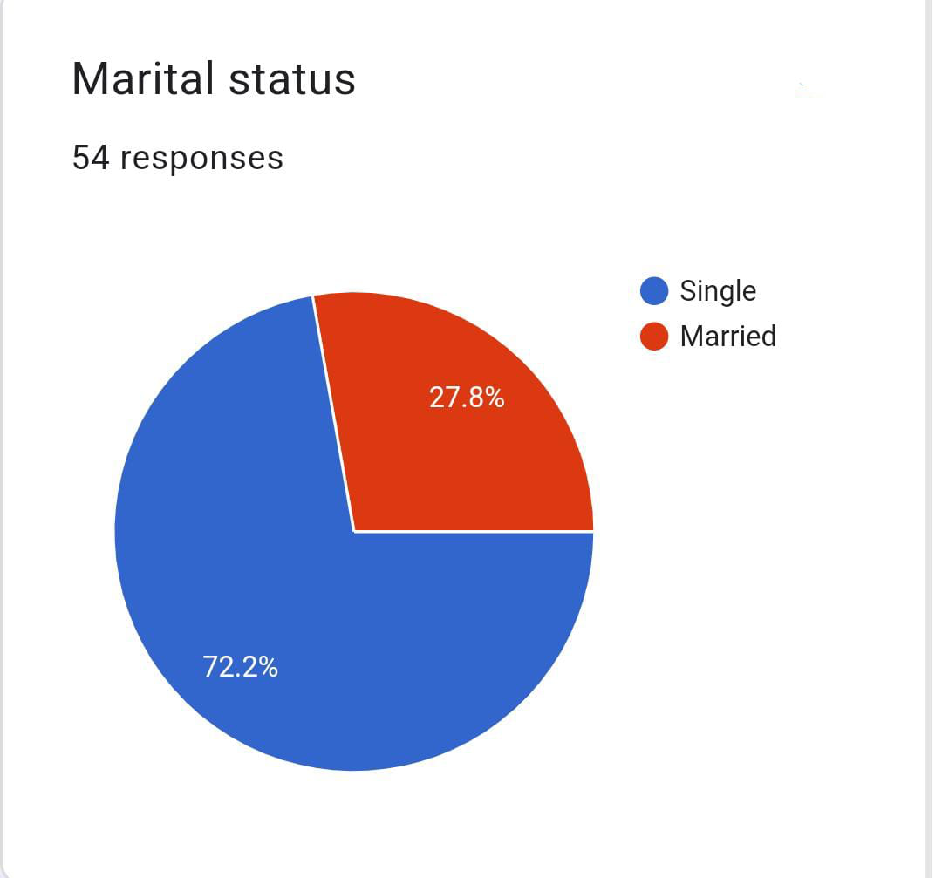

**HOUSEHOLD INCOME**

|  |  |
| --- | --- |
| **OPTION** | **RESPONSES** |
| **UNDER 10K** | **11.1%** |
| **10K-25K** | **9.3%** |
| **25K-73K** | **31.5%** |
| **75K-1LAKH** | **11.1%** |
| **11LAKH** | **9.25** |
|  |  |
|  |  |
|  |  |

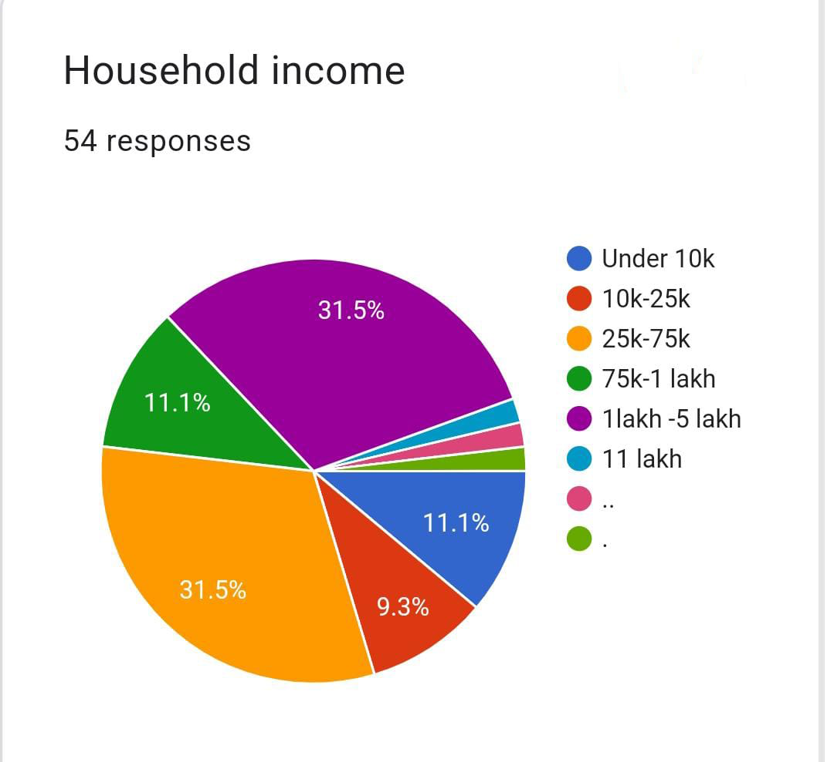

**ARE YOU A MUTUAL INVESTOR**

|  |  |
| --- | --- |
| **OPTION** | **RESPONSES** |
| **YES** | **50** |
| **NO** | **50** |

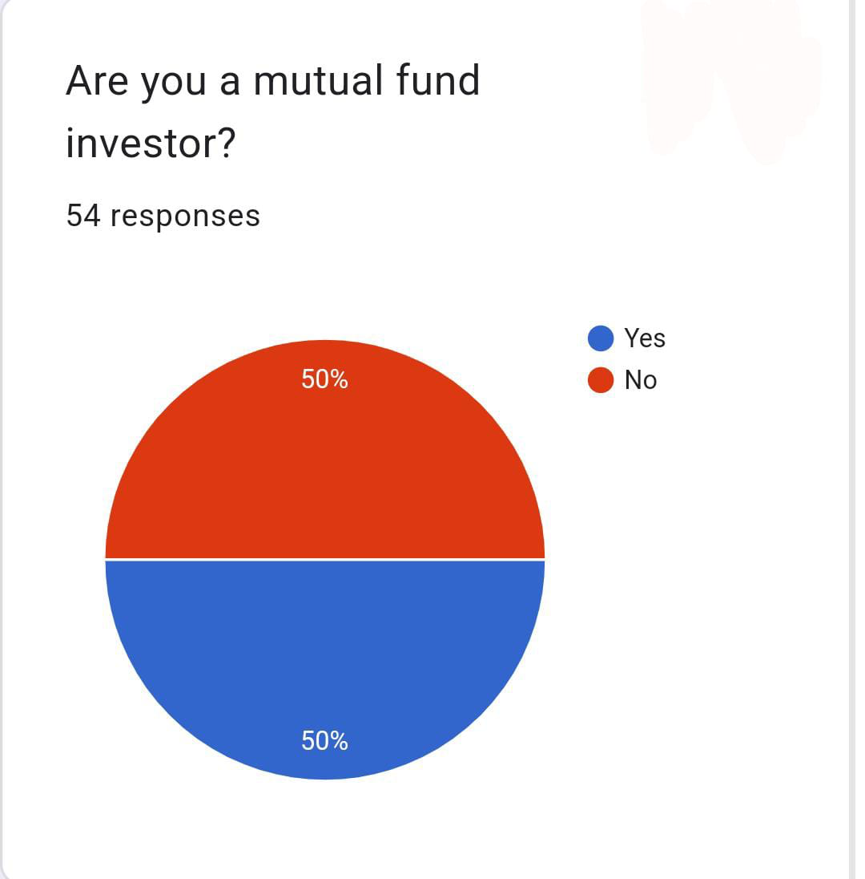

**WHAT’S YOUR INVESTMENT GOAL**

|  |  |
| --- | --- |
| **OPTION** | **RESPONSES** |
| **WEALTH ACCUMULATION** | **42.6%** |
| **RETIREMENT PLANNING** | **7.4%** |
| **EDUCATION FUND FOR CHILDREN** | **16.7%** |
| **OTHER** | **33.3%** |

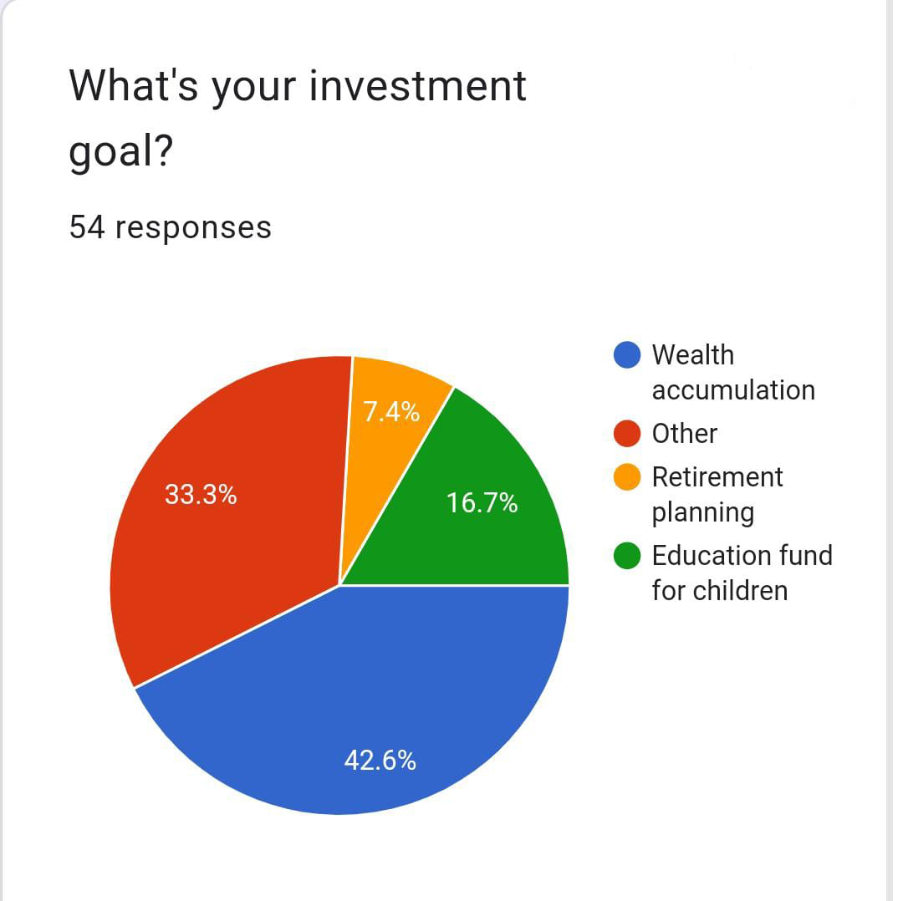

**WHAT IS YOUR RISK TOLERANCE ?**

|  |  |
| --- | --- |
| **OPTIONS** | **RESPONSES** |
| **LOW RISK** | **25.9%** |
| **MODERATE** | **48.1%** |
| **HIGH RISK** | **14.8%** |
| **NOT SURE** | **11.1%** |

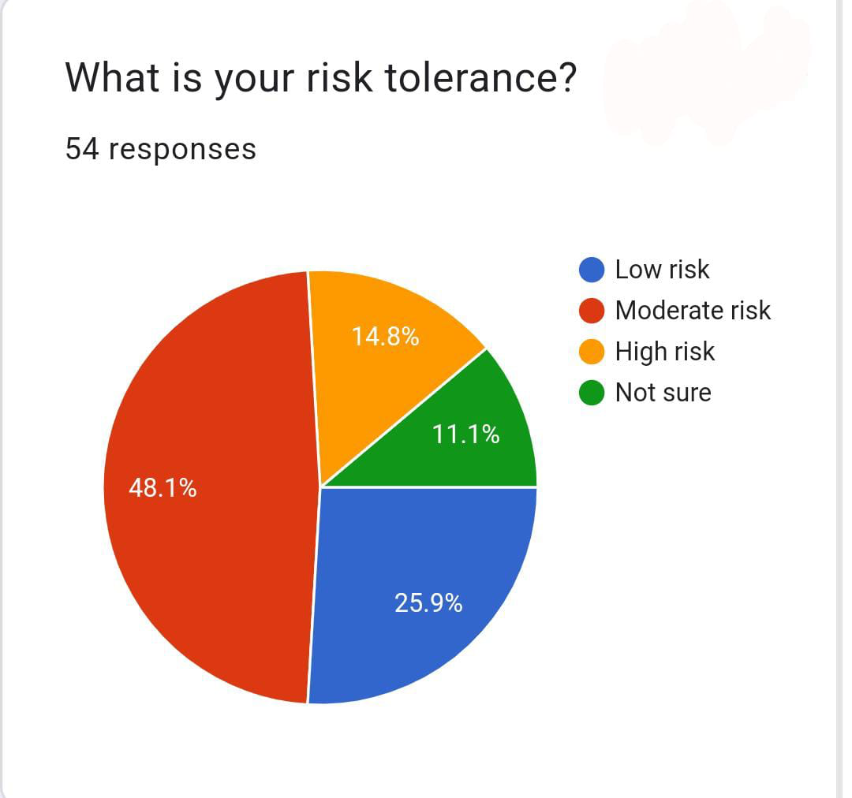

**WHAT IS YOUR INVESTMENT HORIZON ?**

|  |  |
| --- | --- |
| **OPTIONS** | **RESPONSES** |
| **SHORT TERM** | **37%** |
| **MEDIUM TERM** | **31.5%** |
| **LONG TERM** | **31.5%** |

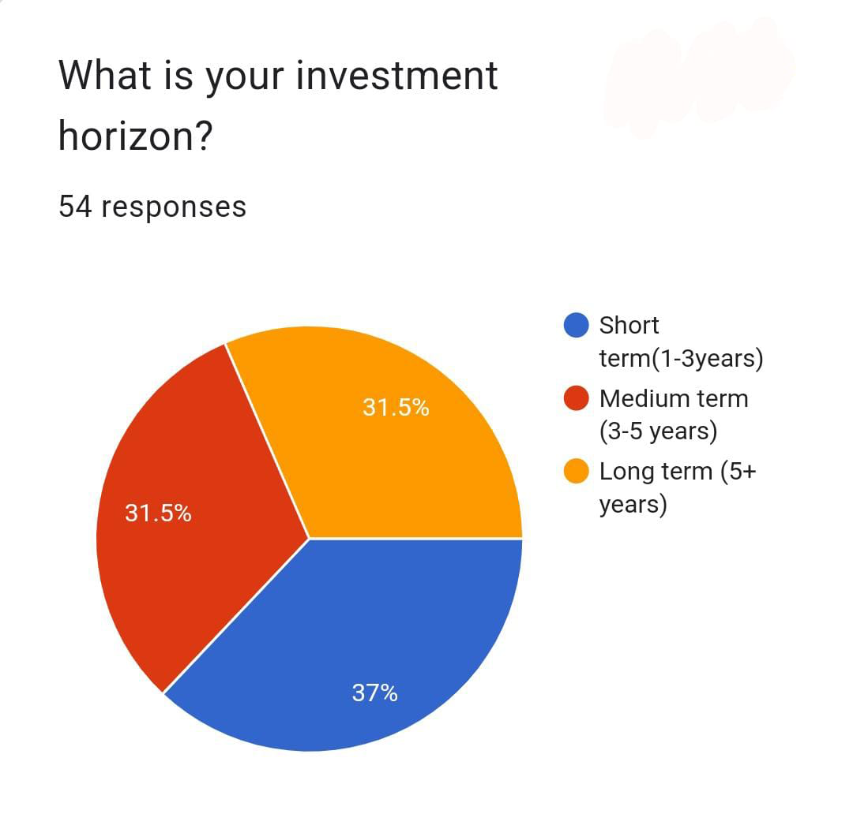

**HOW MUCH ARE YOU PLANNING TO INVEST INITIALLY ?**

|  |  |
| --- | --- |
| **OPTIONS** | **RESPONSES** |
| **LESS THAN 1K** | **25.9%** |
| **1K-5K** | **31.5%** |
| **5K-10K** | **27.8%** |
| **10K ABOVE** | **14.8%** |

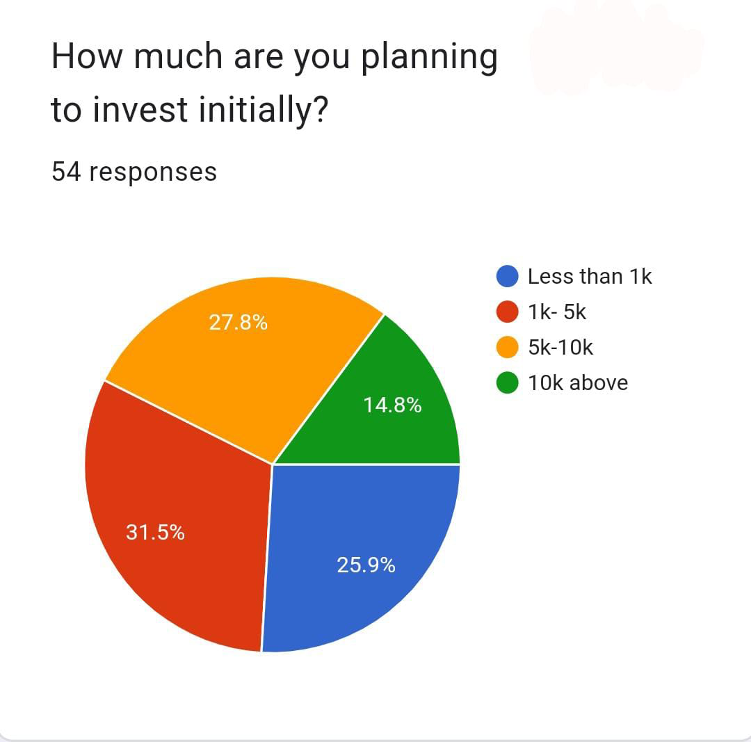

**WHAT TYPE OF MUTUAL FUNDS ARE YOU INTERESTED ?**

|  |  |
| --- | --- |
| **OPTIONS** | **RESPONSES** |
| **EQUITY FUNDES** | **51.9%** |
| **DEBTS FUNDS** | **13%** |
| **HYBRIDE FUNDS** | **22.2%** |
| **SECTOR – SPECIFIC FUNDS** | **7.4%** |
| **NONE** | **5.6%** |

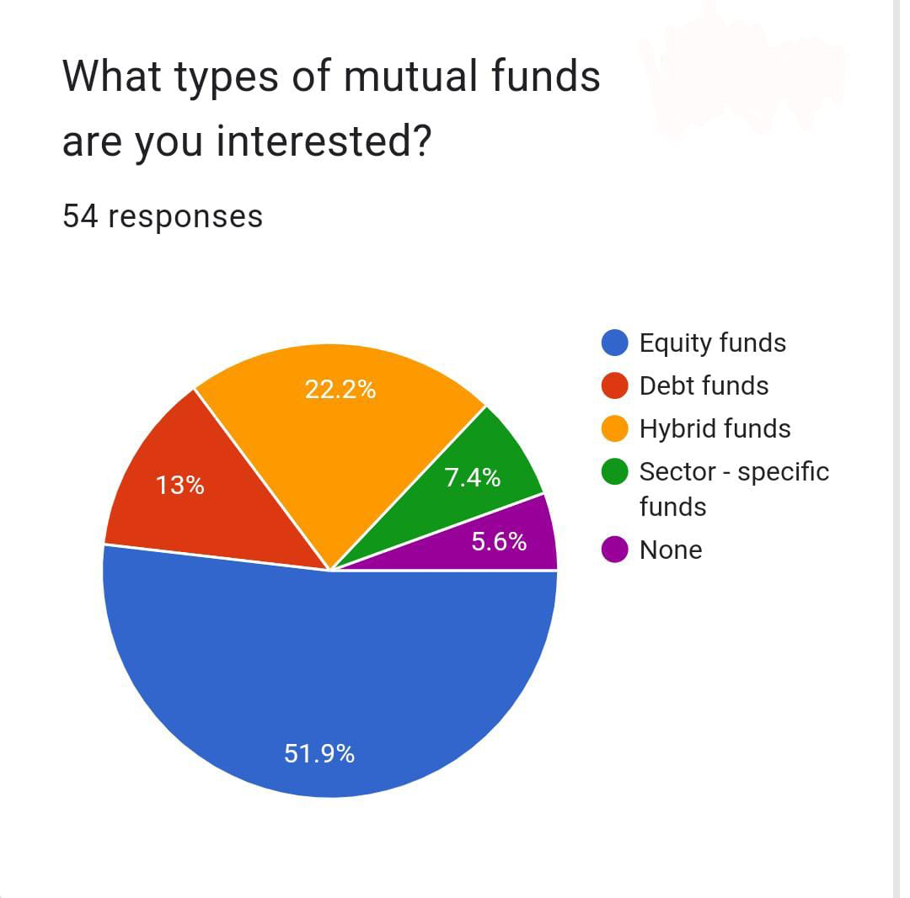

**WHAT IS YOUR PREFERED METHOD OF INVESTING IN MUTUAL FUND**

|  |  |
| --- | --- |
| **OPTIONS** | **RESPONSES** |
| **ONE TIME INVESTMENT** | **20.4%** |
| **SYSTEMATIC INVESTMENT PLAN (SIP)** | **40.7%** |
| **BOTH** | **22.2%** |
| **OTHERS** | **13%** |
| **NONE** | **1.85%** |

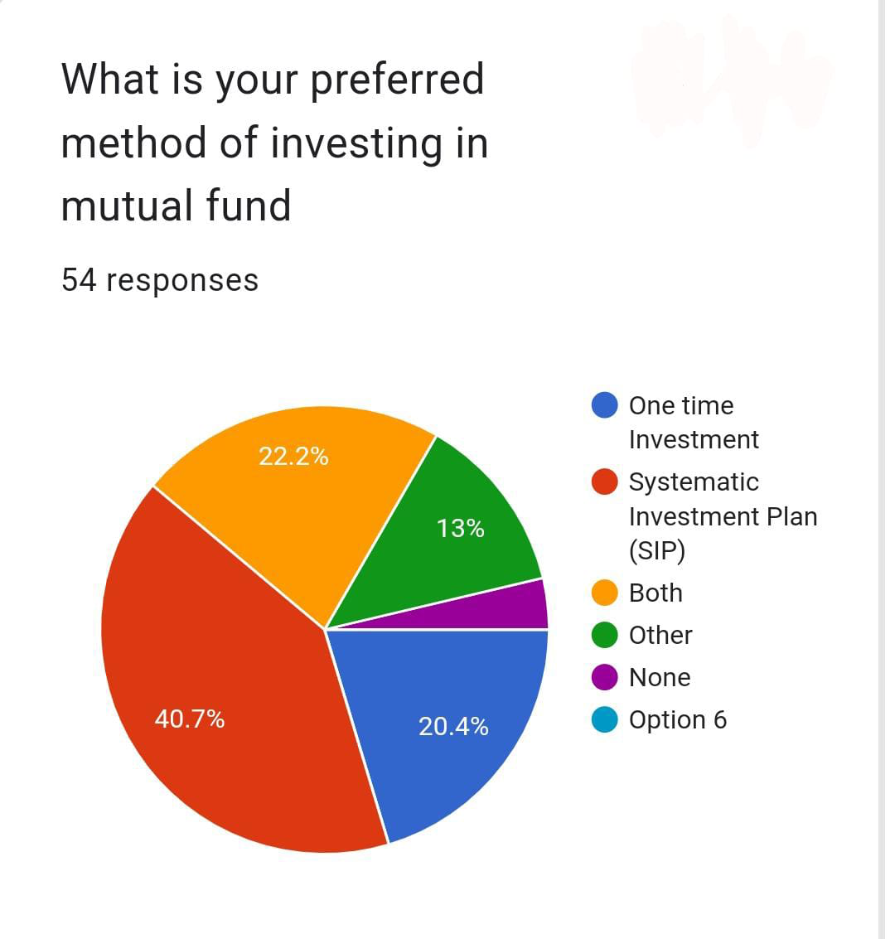

**WHAT IS YOUR PORTFOLIO CONSISTS OF ?**

|  |  |
| --- | --- |
| **OPTIONS** | **RESPONSES** |
| **REAL ESTATE** | **40.7%** |
| **DEBTS** | **22.2%** |
| **DERIVATIVES** |  |
| **NONE** | **7.4%** |
| **EQUITY** | **24.1%** |

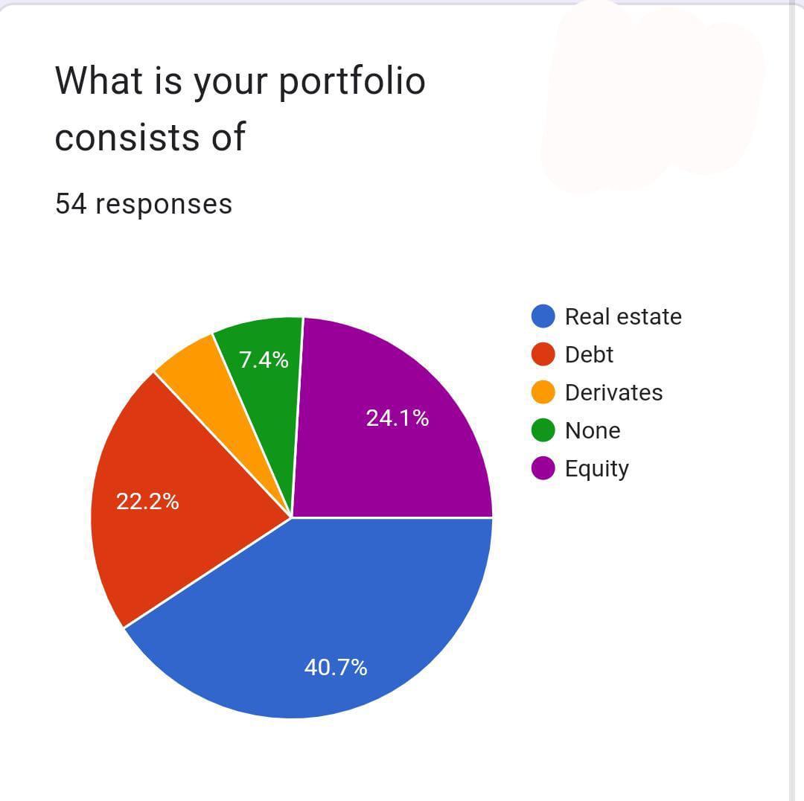

**HOW INVOLVED DO YOU WANT TO BE INMANAGING YOUR INVESTMENT ?**

|  |  |
| --- | --- |
| **OPTIONS** | **RESPONSES** |
| **VERY INVOLVED** | **24.1%** |
| **MODERATELY INVOLVED** | **55.6%** |
| **NOT VERY INVOLVED** | **20.4%** |

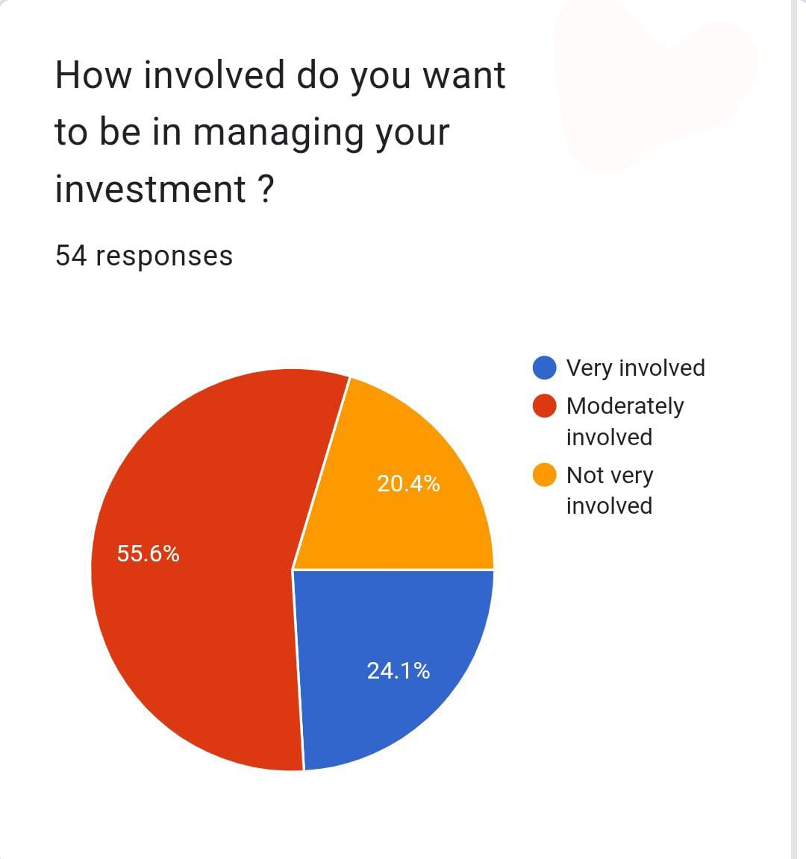

**HOW DO YOU LIKE TO RECEIVE THE RETURNS EVERY YEAR ?**

|  |  |
| --- | --- |
| **OPTIONS** | **RESPONSES** |
| **DIVIDEND PAYOUT** | **37%** |
| **DEVENDEND REINVESTMENT** | **11.1%** |
| **GROWTH IN NAV** | **31.5%** |
| **OTHER** | **20.4%** |

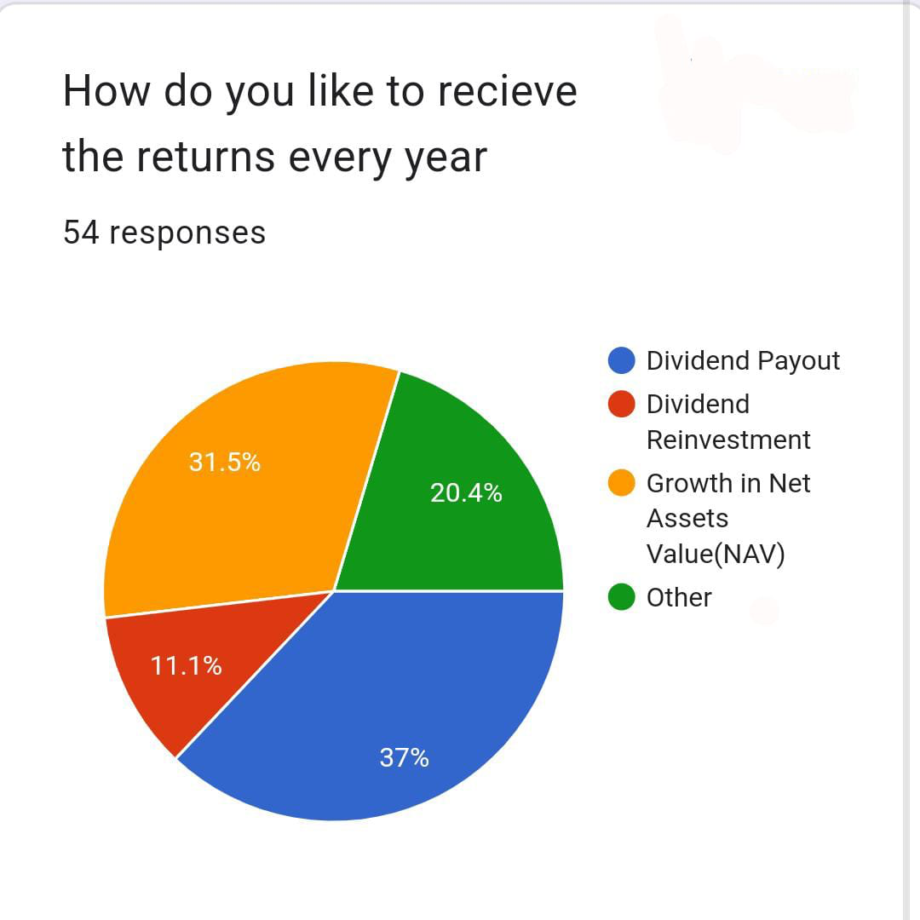

|  |  |
| --- | --- |
| **OPTIONS** | **RESPONSES** |
| **FLEXIBILITY** | **20.4%** |
| **RETURN** | **38.9%** |
| **MANAGED BY PROFESSIONAL PEOPLE** | **24.1%** |
| **RISK DIVERSIONS** | **7.4%** |
| **NONE** | **1.84%** |
| **OTHER** | **1.84%** |

**WHICH FEATURES ATTRACT YOU THE MOST WHILE CHOOSING A SPECIFIC MUTUAL FUND ?**

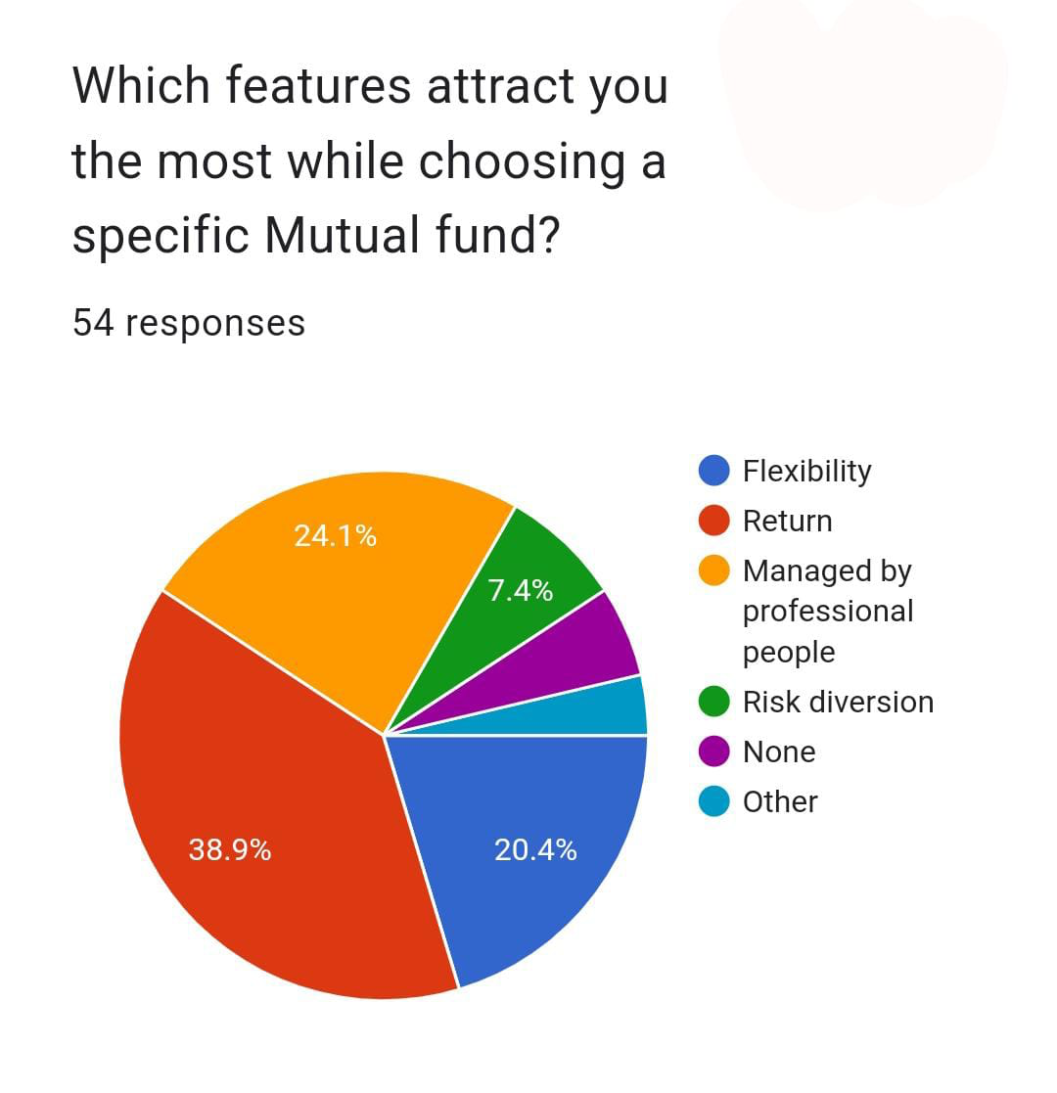

**HOW DO YOU BUY AND SELL MUTUAL FUNDS**

|  |  |
| --- | --- |
| **OPTIONS** | **RESPONSES** |
| **THROUGH FINANCIAL ADVISOR** | **42.6%** |
| **NONE** | **13%** |
| **ONLINE INVESTMENT PLATFORM** | **24.1%** |
| **DIRECTLY THROUGH A MUTUAL FUND COMPANY** | **18.5%** |
| **OTHERS** | **1.84%** |

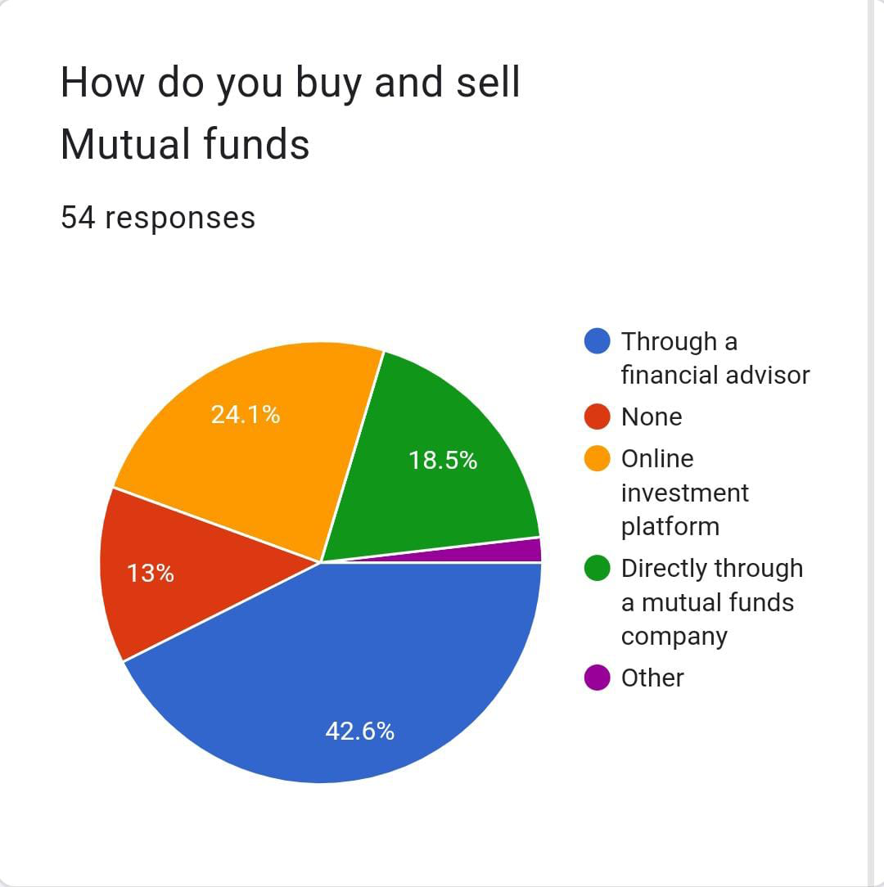

**WHAT IS YOUR PRIMARY GOAL OF INVESTING IN MUTUAL FUNDS.**

|  |  |
| --- | --- |
| **OPTIONS** | **RESPONSES** |
| **CAPITAL APPRECIATION** | **25.9%** |
| **REGULAR INCOME** | **25.9%** |
| **DIVERSIFICATION** | **7.4%** |
| **ALL OF THE ABOVE** | **40.7%** |

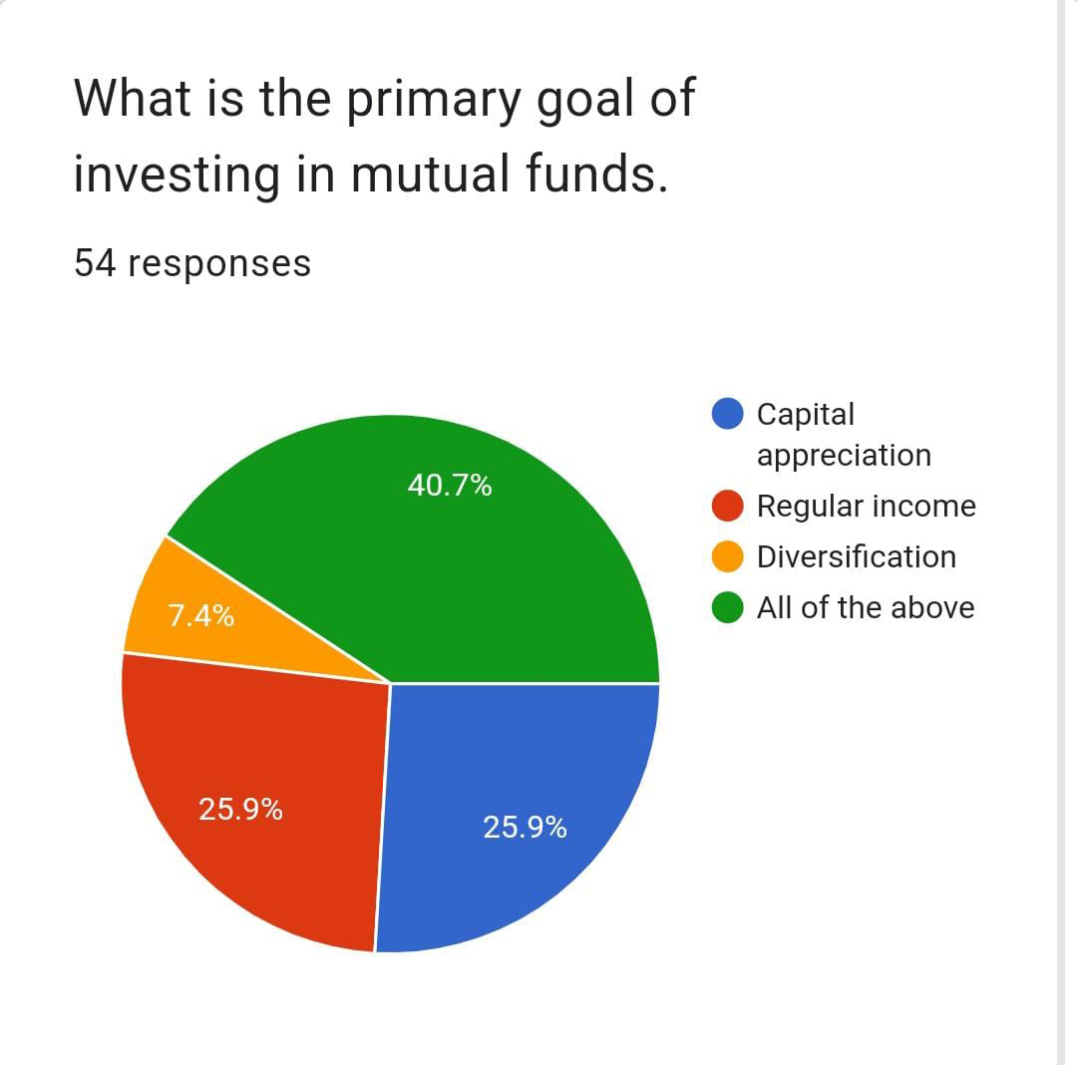

**DO YOU HAVE ANY SPECIFIC INVESTMENT THEMES OR SECTOR YOU WANT TO FOCUS ON WITH MUTUAL FUND ?**

|  |  |
| --- | --- |
| **OPTIONS** | **RESPONSES** |
| **ENVIROMENTAL , SOCIAL AND GOVERNANCE INVESTING** | **25.9%** |
| **TECHNOLOGY AND INNOVATION** | **27.8%** |
| **EMERGING MARKET OR INDUSRY** | **18.5%** |
| **OTHER** | **20.4%** |
| **NONE** | **7.4%** |

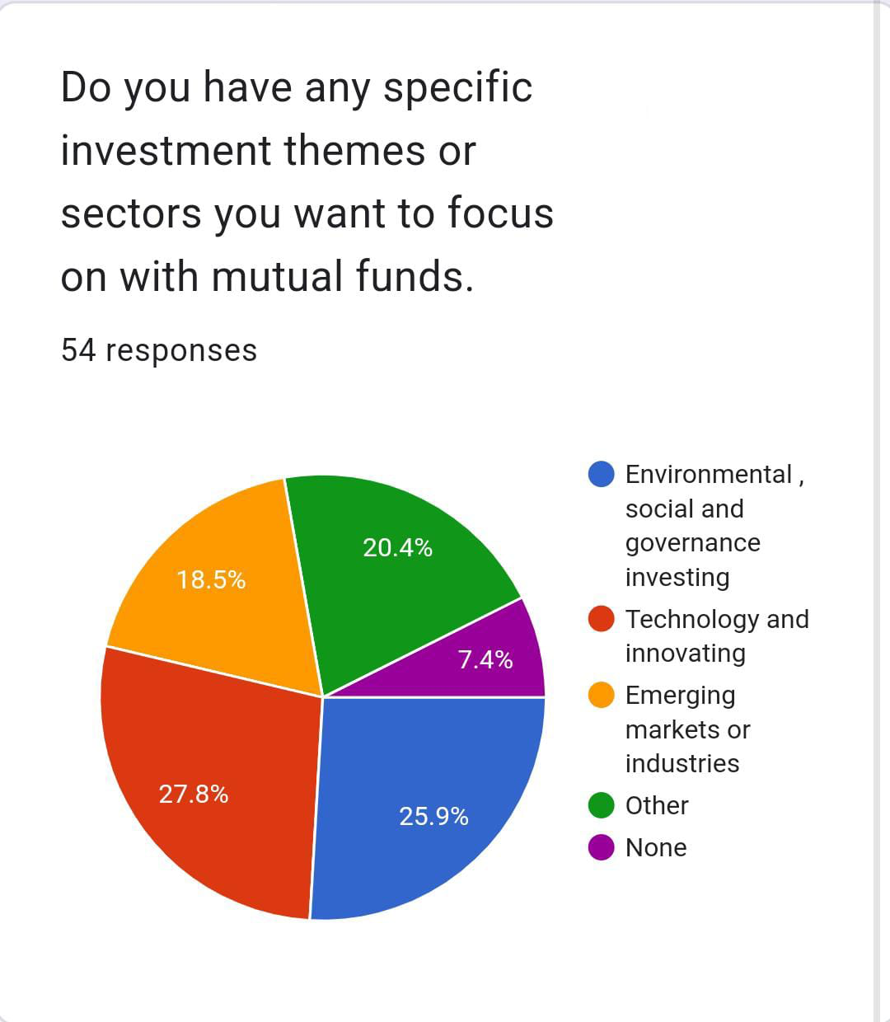

**HOW DO YOU HANDLE MARKET FLUCTUATION AND VOLATILITY IN YOUR MUTUAL FUND INVESTMENT**

|  |  |
| --- | --- |
| **OPTIONS** | **RESPONSES** |
| **STAY INVESTED IN LONG TERM** | **37%** |
| **ADJUSTED ASSEST ALLOCATION** | **18.5%** |
| **MONITOR CLOSELY AND MAKE FREQUENT CHANGE** | **22.2%** |
| **OTHER** | **18.5%** |
| **NONE** | **1.84%** |

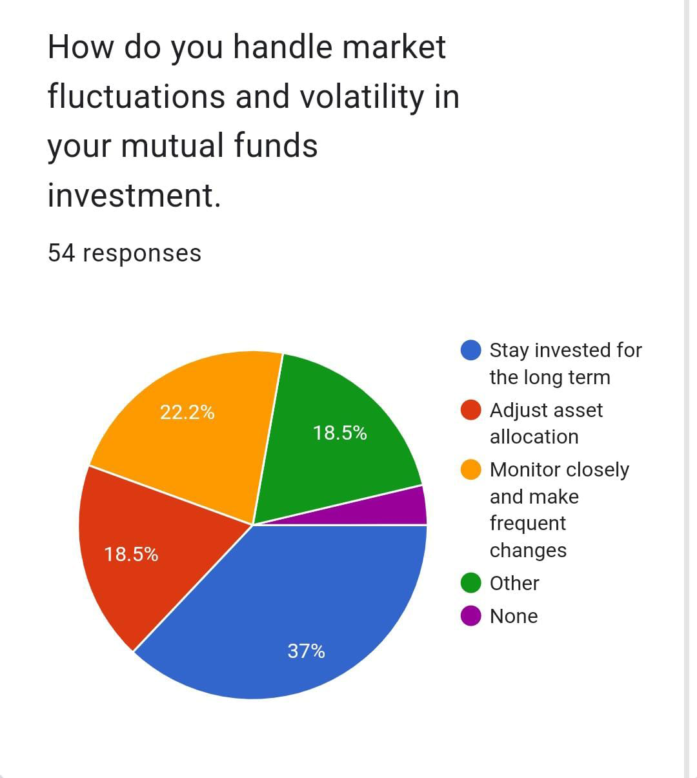

**HOW IMPORTANT IS LIQUIDITY TO YOU IN YOUR MUTUAL FUND INVESTMENT ?**

|  |  |
| --- | --- |
| **OPTIONS** | **RESPONSES** |
| **NOT VERY IMPORTANT** | **29.6%** |
| **MODERATALY** | **44.4%** |
| **VERY IMPORTANT** | **25.9%** |

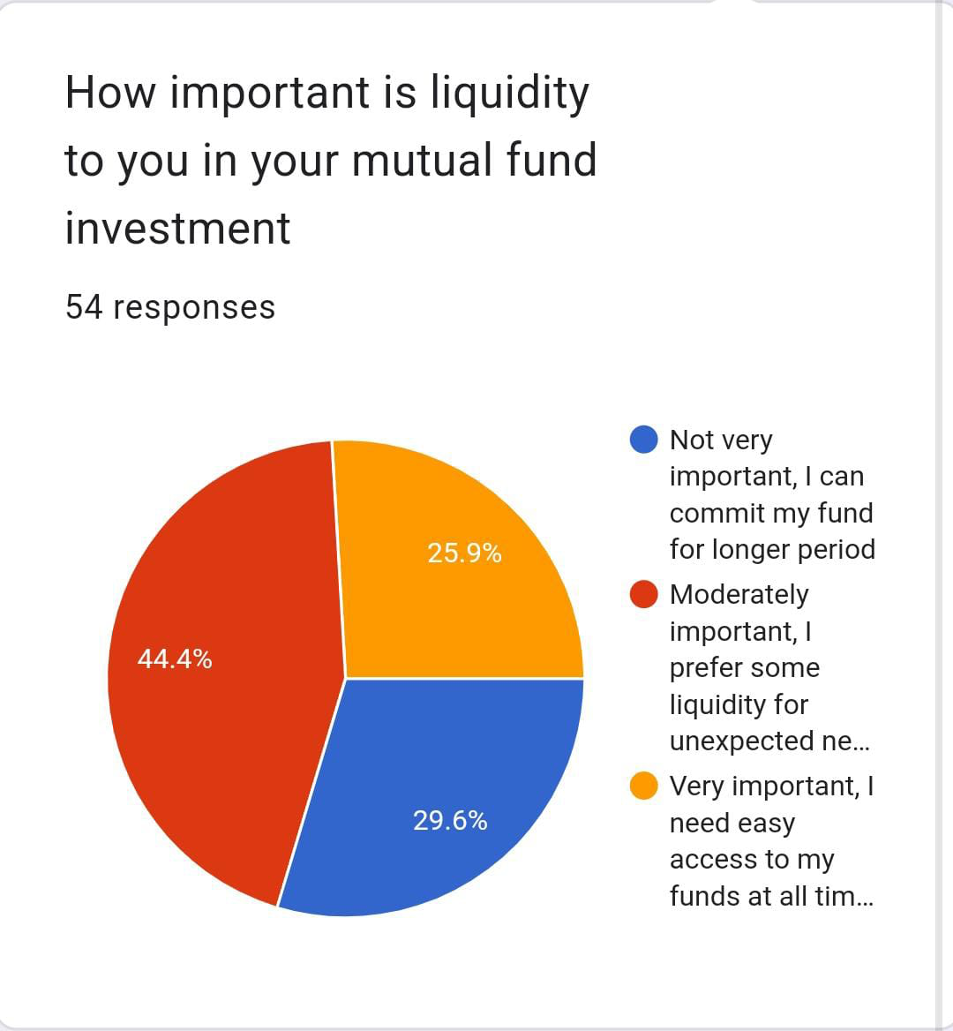

**WHAT IS YOUR OPINION ON IMPORTANCE OF REGULAR PORTFOLIO REBALANCING IN MUTUAL FUND**

|  |  |
| --- | --- |
| **OPTION** | **RESPONSES** |
| **I BELIEVE IN REGULAR REBALANCING** | **35.2 %** |
| **I PREFER MORE FLEXIBLE** | **44.4%** |
| **I AM NOT SURE** | **20.4%** |

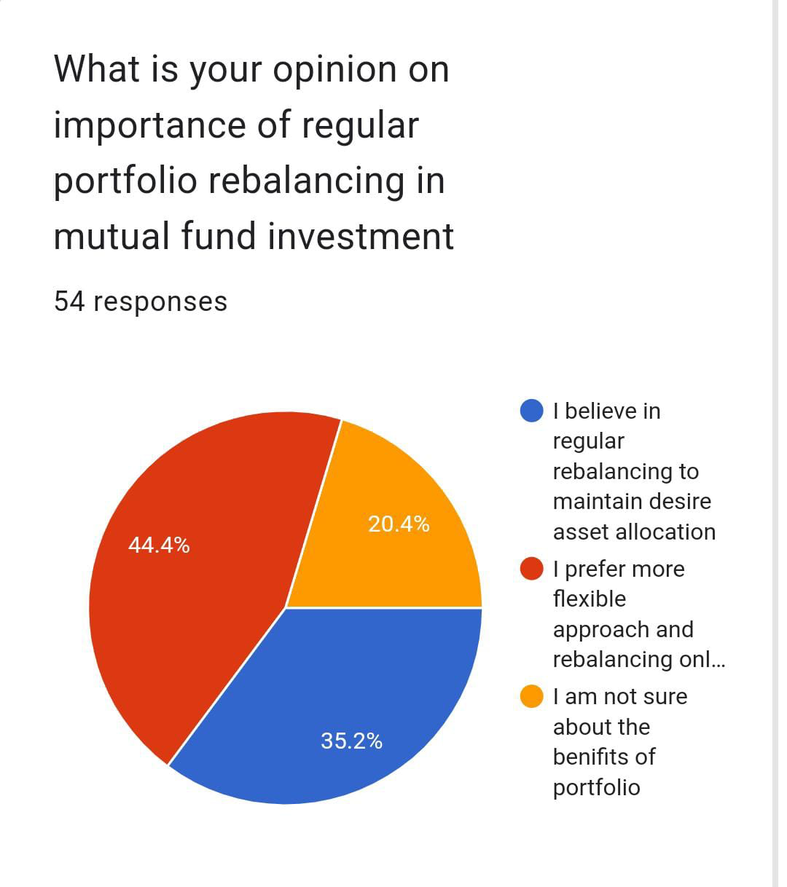

**HOW MUCH PAST PERFORMANCE MUTUAL FUND ACT AS AN INVESTING FACTOR FOR YOU**

|  |  |
| --- | --- |
| **OPTIONS** | **RESPONSES** |
| **VERY IMPORTANT** | **38.9%** |
| **SOMEWHAT IMPORTANT** | **37%** |
| **NOT VERY** | **14.8%** |
| **NOT IMPORTANT** | **9.3%** |

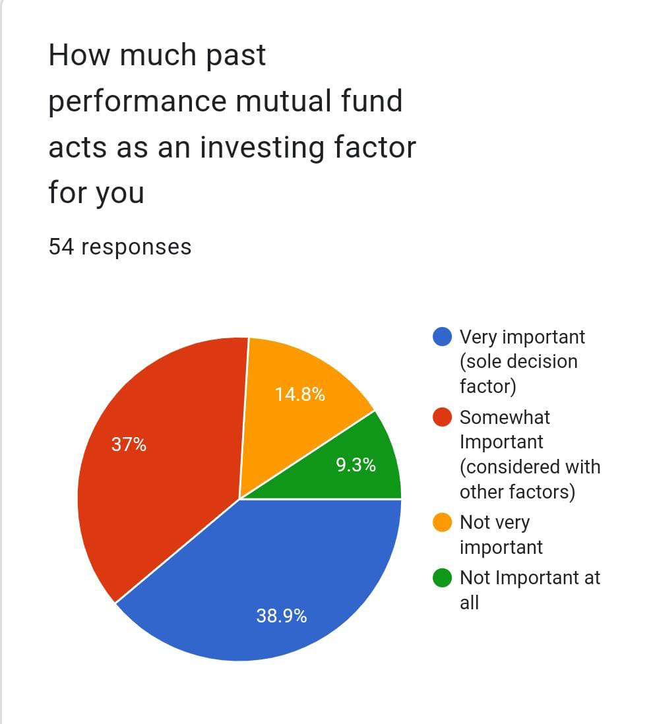

**FINDINGS**

Out of all the responses, we analysed that the proportions of the investors and non investors are almost similar. However, all those who are investing have the wealth accumulation goal. Investors don't want to take higher risk with the view to gain maximum return. Instead, their risk appetite is moderate. Most of them as having little knowledge prefer investing in SIPs.

38.9% of the respondents are attracted to mutual fund because of its regular return feature and also the management by professional experts.

27.8% respondents have their investment in IT sector.

44.4% respondents want their portfolio to be moderately liquid.

38.9% of the respondents rely on the past performances of the mutual fund for their investment decision.

**CONCLUSION**